Kcardia.com / patient Education
Atrial Fibrillation - Patient information

What is atrial fibrillation?

Atrial fibrillation (also called AFib or AF) is a quivering or irregular heartbeat (arrhythmia) that can lead to blood clots, stroke, heart failure. At least 2.7 million Americans are living with AFib.
Here’s how patients have described their experience:
“My heart flip-flops, skips beats, and feels like it’s banging against my chest wall, especially if I’m carrying stuff up my stairs or bending down.”
“I had no symptoms at all. I discovered my AF at a regular check-up. I’m glad we found it early.”

What happens during AFib?
Normally, your heart contracts and relaxes to a regular beat. In atrial fibrillation, the upper chambers of the heart (the atria) beat irregularly (quiver) instead of beating effectively to move blood into the ventricles.
Watch Video
If a clot breaks off, enters the bloodstream and lodges in an artery leading to the brain, a stroke results. This clot risk is why patients with this condition are put on *blood thinners.

AFib Treatment Saves Lives & Lowers Risks
If you or someone you love has atrial fibrillation, learn more about what AFib is, why treatment can save lives, and what you can do to reach your goals, lower your risks and live a healthy life.
If you think you may have atrial fibrillation, here are your most important steps:
- Symptoms: Palpitations, dizziness, chest discomfort, … Or no symptoms at all.
- Treatment to slow down the heart or revert rhythm back to normal and prevent Stroke
- Reduce risk factors for stroke and heart failure: Stop smoking, lower cholesterol,…

(* Some medications are commonly called blood thinners because they can help reduce a blood clot from forming. There are three main types of blood thinners that patients commonly take: anticoagulants like warfarin or heparin, antiplatelet drugs like aspirin, and fibrinolytics like tPA (tissue plasminogen activator). Each type of medication has a specific function to prevent a blood clot from forming or causing a blocked blood vessel, heart attack, or stroke.)

- Stroke prevention (Video 5,36 min)
Watch Video
https://www.youtube.com/watch?v=MW1ZsMLkwfY

2. Cardioversion (Video 2.29 min)
Watch Video
https://youtu.be/dC_i8zuclmQ

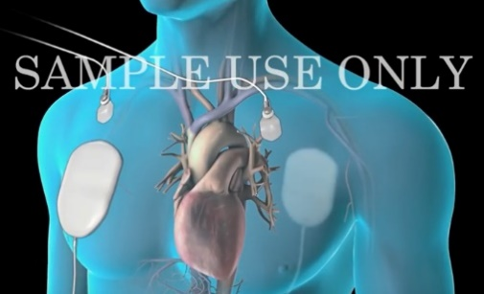

- Watchman device as alternative to blood thinner
Watch Video
https://www.youtube.com/watch?v=gKBzpjwLMKA&ab_channel=NortonHealthcare

